**JOptionPane (Calculator)**

**Requirements:**

* **Java Code ✅**
* **NetBeans IDE ✅**
* **Documentation ✅**

**Groupmates:**

(List here the names of your group and their contribution)

Name : Jhon Brix G. Brion – Java Program Software Development  
Pair : Shane Marie Mon – Java Program Documentation.

**There should be:**

- 2 input value

- use 4 arithmetic operation

- use JOptionPane Dialog Box to do the activity

Note: Only use JOptionPane dialog box for this activity.  
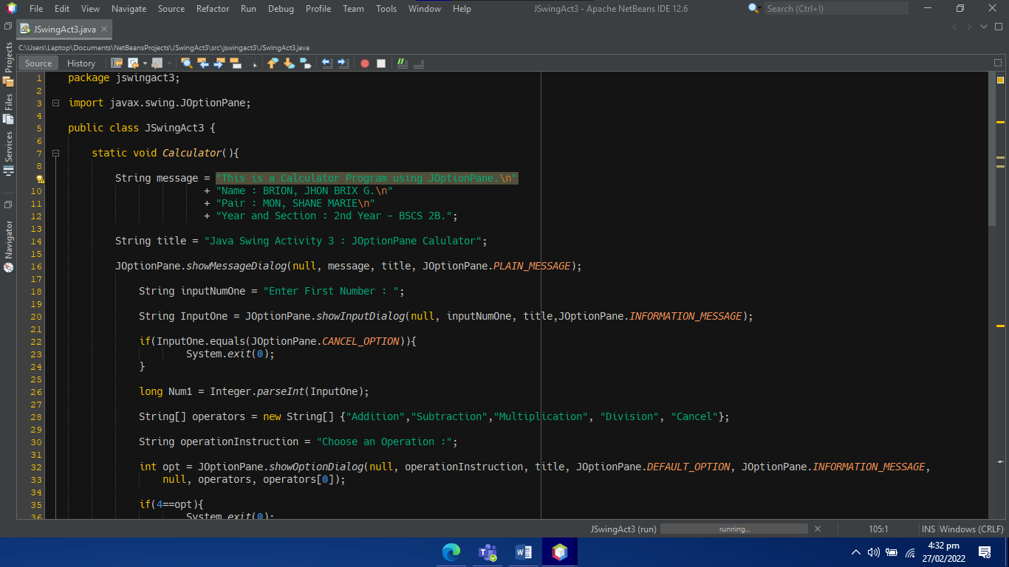

**LAB Activity Problem:**

1. Create a program that will do simple arithmetic operation using JOptionPane Dialog Box:

Java Swing Activity 3 : JOptionPane Calculator (Sum of Numbers)

This is a simple Java Swing Calculator made in JOptionPane Only.

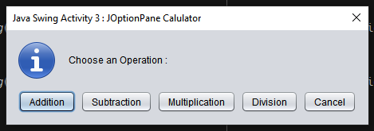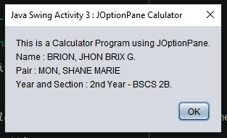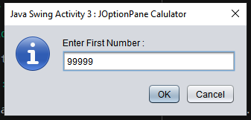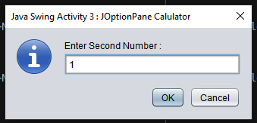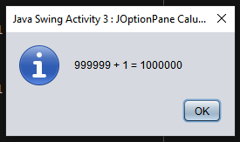  
  
Source Code is in the next page.

